**Propositional Calculus**

Consider the following example:

“On even weekdays, if the sun is out and there are no clouds, I am sad. If the sun is out then there are no clouds. Since I am always Happy, and I live on a planet where all weekdays are even, it is never sunny on my planet”

*--Pay attention to negations--*

The intention of this bizarre paragraph is to emphasis that we do not care if the premises are realistic or true. Instead, we are interested in the logical structure of the paragraph, and the ability to analyse its logical validity.

Let us start by removing all the non-logical content from the paragraph by replacing pieces of information with letters which are called atomic formula. For this we define a dictionary which permits the translation:

(1) A = “It is an even day”.

(2) B = “the sun is out”.

(3) C = “There are no clouds”.

(4) D = “I am sad”.

We can now reformulate the paragraph:

Premise 1: “If A, then if B and C, then D.

Premise 2: If B then C.

Premise 3: Not D and A.

Conclusion: Not B.

Finally let us turn the premises and conclusion to be purely symbolic, for this we need the Logical connectives:

(1) A and B is denoted by A ∧ B. (Conjunction)

(2) A or B is denoted by A ∨ B. (Disjunction)

(3) If A then B is denoted by A ⇒ B. (Implication)

(4) Not A is denoted by ¬A. (Negation)

Finally, our initial paragraph has the following symbolic representation in propositional calculus:

Premise 1: A ⇒ ((B ∧ C) ⇒ D)

Premise 2: B ⇒ C

Premise 3: (¬D) ∧ A

Conclusion: ¬B

1. Formalise the following and, by writing truth tables for the premises and conclusion, determine whether the arguments are valid.

1. Either John isn’t stupid and he is lazy, or he’s stupid. John is stupid. Therefore, John isn’t lazy.
2. The butler and the cook are not both innocent Either the butler is lying or the cook is innocent Therefore, the butler is either lying or guilty

2. Use truth tables to determine which of the following are equivalent to each other:

1. (P ∧ Q) ∨ (¬P ∧ ¬Q)
2. ¬P ∨ Q
3. (P ∨ ¬Q) ∧ (Q ∨ ¬P)
4. ¬(P ∨ Q)
5. (Q ∧ P) ∨ ¬P

Propositional calculus logical identities:

(1) **Commutativity:**

(a) A ∧ B ≡ B ∧ A.

(b) A ∨ B ≡ B ∨ A.

(c) A ⇒ B ≡ B ⇒ A.

**(2) Associativity:**

(a) A ∧ (B ∧ C) ≡ (A ∧ B) ∧ C.

(b) A ∨ (B ∨ C) ≡ (A ∨ B) ∨ C.

**(3) Distributivity law:**

(a) A ∧ (B ∨ C) ≡ (A ∧ B) ∨ (A ∧ C).

(b) A ∨ (B ∧ C) ≡ (A ∨ B) ∧ (A ∨ C).

**(4) Implication identities:**

(a) A ⇒ B ≡ (¬A) ∨ B.

(b) A ⇒ B ≡ (¬B) ⇒ (¬A). (contrapositive)

**(5) Law of negation of logical connectives:**

(a) ¬ (¬(A)) ≡ (A).

(b) ¬ (A ∧ B) ≡ (¬A) ∨ (¬B). (De-Morgan law I)

(c) ¬ (A ∨ B) ≡ (¬A) ∧ (¬B). (De-Morgan law II)

(d) ¬ (A ⇒ B) ≡ A ∧ ¬B.

Alpha-beta Pruning exercises.

Exercise 1:

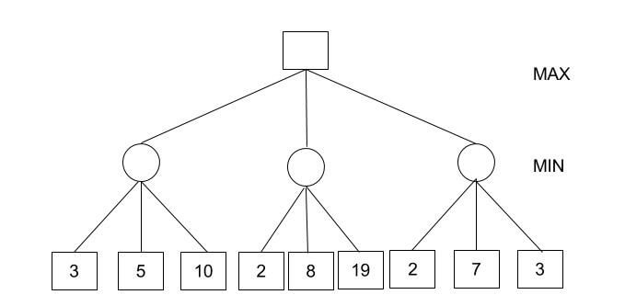

Exercise 2:

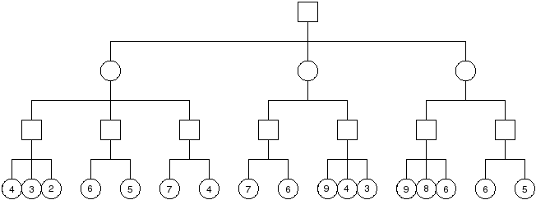

Exercise 3:

